Project Planning Phase
Project Planning Template (Product Backlog, Sprint Planning, Stories, Story Points)
Date | 28 October 2026
Team ID | To Be Confirmed
Project Name | HotelPro – Hotel Management System
Maximum Marks | 5 Marks
Document Status | Draft v1.0 – planned schedule only. Sprint dates are proposed; team members and actual progress are To Be Confirmed / Pending.

1. Introduction and Planning Assumptions
This document is the project plan for HotelPro – Hotel Management System. It contains the product backlog, sprint schedule and estimation, user stories with story points, the project tracker, and the velocity and burndown charts. It follows the reference structure: Product Backlog & Sprint Schedule and Project Tracker, Velocity & Burndown Chart.
Important: this is a plan, not a progress report. No sprint has been executed according to the information provided, so “completed” points, actual release dates and actual velocity are marked Pending. Dates are proposed starting points (To Be Confirmed with the team and faculty guide).

Table 1: Planning parameters
Planning Parameter | Value
Methodology | Scrum-style iterative delivery with two-week sprints
Number of sprints | 7 (proposed)
Sprint length | 2 weeks (10 working days)
Proposed start / end | 2 November 2026 – 5 February 2027 (To Be Confirmed)
Total planned story points | 157
Team size / members | To Be Confirmed
Estimation scale | Story points: 2, 3, 5, 8 (relative effort incl. development, testing, documentation)
Priority scale | High = required for MVP; Medium = needed for complete scope; Low = nice-to-have within scope

2. Product Backlog and Sprint Schedule
The backlog lists every user story (USN) grouped by sprint and epic. Detailed acceptance criteria are in the Data Flow Diagram & User Stories document.
Table 2: Product backlog and sprint schedule
Sprint | Functional Requirement (Epic) | User Story Number | User Story / Task | Story Points | Priority | Team Members
Sprint-1 | Project Setup | USN-1 | As a developer, I can set up the repository, environment variables and MongoDB connection so the team works on a shared baseline. | 3 | High | To Be Confirmed
 | Authentication | USN-2 | As a guest, I can register with name, email and password. | 5 | High | To Be Confirmed
 | Authentication | USN-3 | As a user, I can log in and receive a signed JWT so that I can access protected pages. | 3 | High | To Be Confirmed
 | Authentication | USN-4 | As a guest, I can verify my email address through a link sent to me. | 3 | Medium | To Be Confirmed
 | Role-Based Security | USN-5 | As a user, I can only open pages and APIs allowed for my role. | 5 | High | To Be Confirmed
 | Authentication | USN-6 | As a user, I can reset a forgotten password. | 3 | Medium | To Be Confirmed
Sprint-2 | Room Inventory | USN-7 | As a hotel manager, I can add and edit rooms and room categories with base prices. | 5 | High | To Be Confirmed
 | Room Inventory | USN-8 | As a hotel manager, I can upload room images. | 3 | Medium | To Be Confirmed
 | Room Browsing | USN-9 | As a guest, I can browse the list of rooms with pagination. | 3 | High | To Be Confirmed
 | Room Search | USN-10 | As a guest, I can search and filter rooms by dates, guests, type and price. | 5 | High | To Be Confirmed
 | Room Browsing | USN-11 | As a guest, I can view room details, amenities and reviews. | 2 | High | To Be Confirmed
 | Hotel Management | USN-12 | As a admin, I can create and manage hotel records. | 3 | Medium | To Be Confirmed
Sprint-3 | Booking | USN-13 | As a guest, I can book an available room for chosen dates. | 8 | High | To Be Confirmed
 | Booking | USN-14 | As a guest, I am prevented from booking a room that is already reserved for overlapping dates. | 5 | High | To Be Confirmed
 | Booking History | USN-15 | As a guest, I can view my booking history and status. | 3 | High | To Be Confirmed
 | Booking Modification | USN-16 | As a hotel manager, I can approve or reject a guest's change request for dates or room. | 5 | Medium | To Be Confirmed
 | Cancellation | USN-17 | As a guest, I can cancel a booking according to the cancellation policy. | 3 | High | To Be Confirmed
Sprint-4 | Online Payment | USN-18 | As a guest, I can pay for a booking online. | 8 | High | To Be Confirmed
 | Online Payment | USN-19 | As a guest, My payment is verified server-side before confirmation. | 5 | High | To Be Confirmed
 | Refunds | USN-20 | As a guest, I can request a refund for an eligible cancellation. | 5 | Medium | To Be Confirmed
 | Notifications | USN-21 | As a guest, I receive email confirmations for key booking events. | 3 | Medium | To Be Confirmed
 | Notifications | USN-22 | As a user, I can see in-app notifications and mark them as read. | 3 | Medium | To Be Confirmed
Sprint-5 | Check-In / Check-Out | USN-23 | As a staff, I can check a guest in against a confirmed booking. | 3 | High | To Be Confirmed
 | Check-In / Check-Out | USN-24 | As a staff, I can check a guest out and settle the final bill. | 3 | High | To Be Confirmed
 | Room Status | USN-25 | As a staff, I can update the status of a room. | 2 | High | To Be Confirmed
 | Housekeeping | USN-26 | As a staff, I can view and complete housekeeping tasks. | 3 | Medium | To Be Confirmed
 | Service Requests | USN-27 | As a guest, I can request a hotel service during my stay. | 3 | Medium | To Be Confirmed
 | Seasonal Pricing | USN-28 | As a hotel manager, I can define seasonal pricing rules. | 5 | Medium | To Be Confirmed
 | Staff Assignment | USN-29 | As a hotel manager, I can assign staff to tasks and shifts. | 3 | Medium | To Be Confirmed
 | Occupancy Monitoring | USN-30 | As a hotel manager, I can monitor current and forecast occupancy. | 3 | Medium | To Be Confirmed
Sprint-6 | Reviews | USN-31 | As a guest, I can rate and review a completed stay. | 3 | Medium | To Be Confirmed
 | Customer Support | USN-32 | As a guest, I can raise a support request and receive a reply. | 3 | Low | To Be Confirmed
 | Administration | USN-33 | As a admin, I can manage users and staff accounts. | 3 | High | To Be Confirmed
 | Payment Tracking | USN-34 | As a admin, I can track all payments and refunds. | 3 | Medium | To Be Confirmed
 | Reports and Analytics | USN-35 | As a admin, I can view booking, occupancy and revenue reports with charts. | 5 | Medium | To Be Confirmed
 | Security Monitoring | USN-36 | As a admin, I can review activity and security logs. | 3 | Medium | To Be Confirmed
 | Platform Configuration | USN-37 | As a admin, I can configure platform settings such as cancellation policy and tax rate. | 2 | Low | To Be Confirmed
Sprint-7 | Security Hardening | USN-38 | As a developer, I can ensure all inputs are validated and sanitised. | 5 | High | To Be Confirmed
 | Responsive Design | USN-39 | As a guest, I can use the application comfortably on mobile and tablet. | 3 | Medium | To Be Confirmed
 | Testing | USN-40 | As a tester, I can execute the planned test cases and log defects. | 5 | High | To Be Confirmed
 | Performance | USN-41 | As a developer, I can add database indexes and pagination to heavy queries. | 3 | Medium | To Be Confirmed
 | Deployment | USN-42 | As a developer, I can deploy the application to a hosted environment. | 3 | Medium | To Be Confirmed

3. Sprint Schedule and Estimation
Table 3: Sprint schedule and estimation
Sprint | Sprint Goal | Duration | Planned Start | Planned End | Story Points | Key Dependencies | Deliverables | Completion Criteria
Sprint-1  Foundation and Authentication | Working project skeleton with registration, login, email verification and role protection. | 10 working days | 2 Nov 2026 | 13 Nov 2026 | 22 | Repository, environment, database connection | Auth APIs and UI; RBAC middleware; setup guide | Auth test cases executed; roles enforced
Sprint-2  Hotel, Room Inventory and Search | Hotels, rooms and categories managed; guests can browse, search and view rooms. | 10 working days | 16 Nov 2026 | 27 Nov 2026 | 21 | Sprint 1 authentication and roles | Inventory and search APIs/UI; image upload | Search returns correct filtered results
Sprint-3  Booking and Availability | Guests can book without conflicts, view history, cancel and request changes. | 10 working days | 30 Nov 2026 | 11 Dec 2026 | 24 | Sprint 2 rooms and pricing data | Booking APIs/UI; availability logic; history; cancellation | No overlapping bookings under concurrent test
Sprint-4  Payments and Notifications | Payments verified server-side; refunds and notifications in place. | 10 working days | 14 Dec 2026 | 25 Dec 2026 | 24 | Sprint 3 bookings; payment gateway and SMTP test accounts | Payment flow; refund workflow; email and in-app notifications | Booking confirmed only after verified payment
Sprint-5  Hotel Operations and Pricing | Staff operations, housekeeping, service requests, seasonal pricing and occupancy view. | 10 working days | 28 Dec 2026 | 8 Jan 2027 | 25 | Sprint 3–4 (bookings, payments) | Check-in/out, room status, housekeeping, services, pricing rules, occupancy dashboard | Operations scenarios executed in UAT
Sprint-6  Reviews, Administration and Reports | Reviews, support, admin management, payment tracking, reports, logs and configuration. | 10 working days | 11 Jan 2027 | 22 Jan 2027 | 22 | Sprints 3–5 data for reports | Reviews, tickets, admin console, payment tracking, report charts, logs, settings | Report totals match source data
Sprint-7  Hardening, Testing and Release | Security hardening, responsive polish, executed test cases, indexes and deployment. | 10 working days | 25 Jan 2027 | 5 Feb 2027 | 19 | All earlier sprints | Hardened validation, responsive UI, test report, deployed build | All High-priority test cases executed; open critical defects = 0

3.1 Estimation Summary by Epic Area
Table 4: Story points by epic
Epic | Stories | Story Points
Project Setup | 1 | 3
Authentication | 4 | 14
Role-Based Security | 1 | 5
Room Inventory | 2 | 8
Room Browsing | 2 | 5
Room Search | 1 | 5
Hotel Management | 1 | 3
Booking | 2 | 13
Booking History | 1 | 3
Booking Modification | 1 | 5
Cancellation | 1 | 3
Online Payment | 2 | 13
Refunds | 1 | 5
Notifications | 2 | 6
Check-In / Check-Out | 2 | 6
Room Status | 1 | 2
Housekeeping | 1 | 3
Service Requests | 1 | 3
Seasonal Pricing | 1 | 5
Staff Assignment | 1 | 3
Occupancy Monitoring | 1 | 3
Reviews | 1 | 3
Customer Support | 1 | 3
Administration | 1 | 3
Payment Tracking | 1 | 3
Reports and Analytics | 1 | 5
Security Monitoring | 1 | 3
Platform Configuration | 1 | 2
Security Hardening | 1 | 5
Responsive Design | 1 | 3
Testing | 1 | 5
Performance | 1 | 3
Deployment | 1 | 3
Total | 42 | 157

4. User Stories and Story Points
Story points express relative effort. 2 points = small, well-understood change; 3 = moderate; 5 = complex or cross-layer; 8 = large, high-risk feature (booking creation, online payment). Stories larger than 8 should be split. The full story list with acceptance criteria is maintained in the Data Flow Diagram & User Stories document; the table in Section 2 shows points and priority.
Table 5: Backlog by priority
Priority | Stories | Story Points | Share
High | 20 | 84 | 54%
Medium | 20 | 68 | 43%
Low | 2 | 5 | 3%

5. Project Tracker
The tracker below follows the reference format. “Story Points Completed” and “Sprint Release Date (Actual)” are Pending and must be updated at the end of each sprint.
Table 6: Project tracker
Sprint | Total Story Points | Duration | Sprint Start Date (Planned) | Sprint End Date (Planned) | Story Points Completed (as on Planned End Date) | Sprint Release Date (Actual) | Status
Sprint-1 | 22 | 2 weeks (10 working days) | 2 Nov 2026 | 13 Nov 2026 | Pending | Pending | Not Started
Sprint-2 | 21 | 2 weeks (10 working days) | 16 Nov 2026 | 27 Nov 2026 | Pending | Pending | Not Started
Sprint-3 | 24 | 2 weeks (10 working days) | 30 Nov 2026 | 11 Dec 2026 | Pending | Pending | Not Started
Sprint-4 | 24 | 2 weeks (10 working days) | 14 Dec 2026 | 25 Dec 2026 | Pending | Pending | Not Started
Sprint-5 | 25 | 2 weeks (10 working days) | 28 Dec 2026 | 8 Jan 2027 | Pending | Pending | Not Started
Sprint-6 | 22 | 2 weeks (10 working days) | 11 Jan 2027 | 22 Jan 2027 | Pending | Pending | Not Started
Sprint-7 | 19 | 2 weeks (10 working days) | 25 Jan 2027 | 5 Feb 2027 | Pending | Pending | Not Started

6. Velocity and Burndown Chart

6.1 Velocity
Velocity is the number of story points actually completed in a sprint. No actual velocity exists yet. The chart shows the points planned per sprint (average planned load ≈ 22.4 points). After Sprint 1 the team should record its actual completed points and re-balance later sprints.
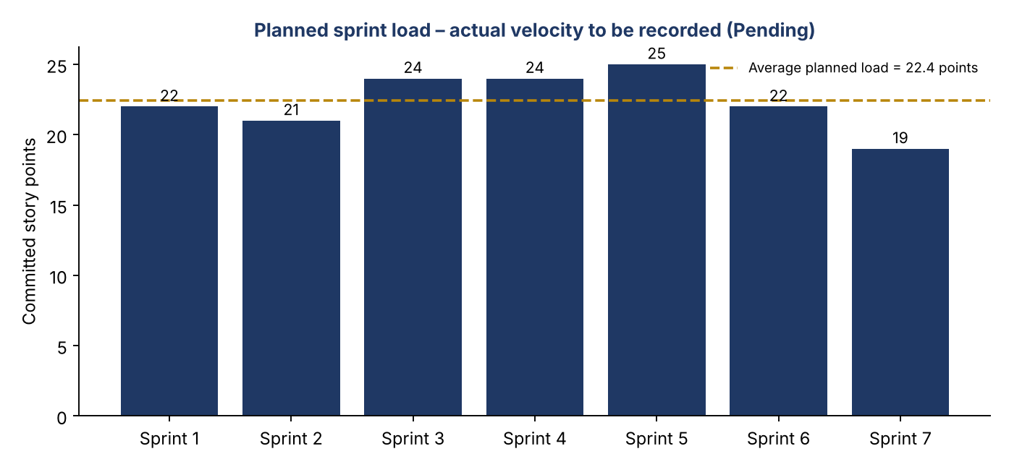
Figure 1: Planned sprint load (committed story points per sprint)
Table 7: Velocity record (to be completed)
Sprint | Planned Points | Actual Points Completed | Velocity (Actual ÷ Sprint)
Sprint-1 | 22 | Pending | Pending
Sprint-2 | 21 | Pending | Pending
Sprint-3 | 24 | Pending | Pending
Sprint-4 | 24 | Pending | Pending
Sprint-5 | 25 | Pending | Pending
Sprint-6 | 22 | Pending | Pending
Sprint-7 | 19 | Pending | Pending

6.2 Burndown
Average velocity = total points completed ÷ number of completed sprints. Sprint burndown = points remaining versus days; release burndown = points remaining versus sprints. The chart below is the planned release burndown only; the actual line is added as sprints finish.
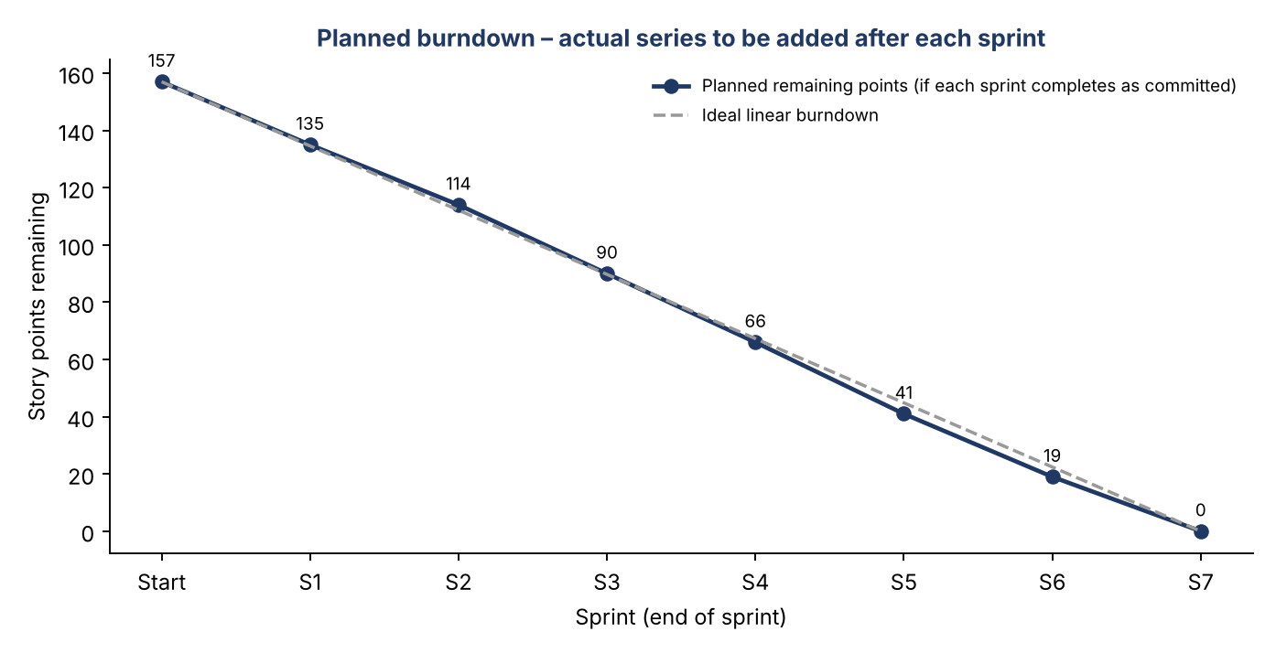
Figure 2: Planned release burndown (actual series Pending)

7. Dependencies and Risks
Table 8: Dependencies and risks
ID | Dependency / Risk | Affected Sprint | Mitigation
R1 | Payment gateway choice and test account not yet confirmed | 4 | Decide by end of Sprint 2; build behind a payment-service interface
R2 | SMTP account for verification and notification emails | 1, 4 | Use sandbox mail service for development
R3 | Concurrency handling for double-booking (transactions need replica set) | 3 | Use Atlas or local replica set; prototype early in Sprint 3
R4 | Report accuracy depends on clean booking/payment data | 6 | Seed realistic test data; verify with manual calculations
R5 | Team availability and exam schedule | All | Re-plan at each sprint review; protect High-priority stories
R6 | Scope growth (Future ideas) | All | Keep Future items out of the sprint backlog

8. Definition of Done
- Code reviewed and merged; no secrets committed.
- Server and client validation implemented for new inputs.
- Role-based access checked for new endpoints and pages.
- Related test cases executed and results recorded (no result is recorded before execution).
- Documentation (requirements, API, test cases) updated.
- Demonstrated at sprint review and accepted against the story’s acceptance criteria.

References
- Scrum Guide – https://scrumguides.org/scrum-guide.html
- Atlassian – Story Points and Estimation – https://www.atlassian.com/agile/project-management/estimation
- Atlassian – Burndown Charts – https://www.atlassian.com/agile/tutorials/burndown-charts
- Atlassian – Velocity – https://www.atlassian.com/agile/project-management/velocity-scrum

